**Ideation Phase**

**Define the Problem Statements**

|  |  |
| --- | --- |
| Date | 26 September 2022 |
| Team ID | PNT2022TMID07973 |
| Project Name | Project – PERSONAL EXPENSE TRACKER APPLICATION. |

**Customer Problem Statement Template:**

Tracking the spending is always being aware of one’s personal finances. Tracking what we spend can help us stick to our budget, not just in a general way, but in each category. Manually tracking all cash that is spent can be time consuming, hence doing that automatically can be quick and simple.

If someone wish to track spending by entering data onto a computer [**spreadsheet**](https://www.easytechjunkie.com/what-is-a-spreadsheet.htm), hence these options should also be available.

**Example:**

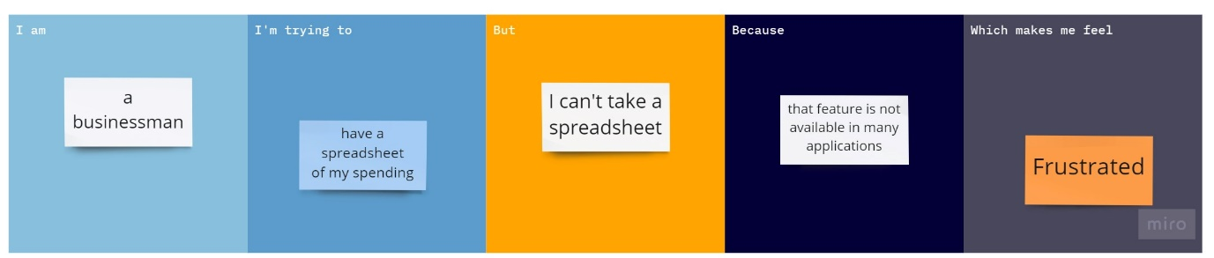

|  |  |  |  |  |  |
| --- | --- | --- | --- | --- | --- |
| **Problem Statement (PS)** | **I am (Customer)** | **I’m trying to** | **But** | **Because** | **Which makes me feel** |
| PS-1 | A businessman | get a spreadsheet of my spending | I can’t take a spreadsheet | that feature is not available in many applications | frustrated |
| PS-2 | A finance manager | Feed the income and spending automatically | I fed the expenses manually | There is no feature of automatic feeind of expenses | annoyed |